VIT Bhopal University
PROJECT REPORT
BUS RESERVATION SYSTEM
A console-based application developed in Python
Submitted by
Himani Paliwal
Registration No.: 26BAI10212
Submitted to
Venkat Prasad Padhy

2. Introduction
Travelling by bus is one of the most widely used modes of public transport, and every bus operator needs a dependable way to record which seats are booked and by whom. When this is done on paper, it is slow and prone to mistakes such as the same seat being sold twice.
The Bus Reservation System is a menu-driven console application written in Python 3. It works like a small ticket counter: the operator can see the list of buses, check the status of every seat, book a seat for a passenger, cancel a booking, and view the details of all passengers. The program uses only Python’s built-in features (dictionaries, functions, loops, conditions and exception handling) and needs no external library or database.
The system currently manages three buses (Bhopal to Udaipur, Udaipur to Kolar and Udaipur to Delhi) with ten seats in each bus. The project is meant to demonstrate good program structure and the logic of a reservation system, and to serve as a base that can later be extended with permanent storage and a graphical or web interface.

3. Problem Statement
Manual seat booking with registers or paper charts has the following problems:
- The same seat can accidentally be allotted to two passengers (double booking).
- Finding out how many seats are still free on a bus takes time.
- Cancelling a ticket and freeing the seat depends on the operator updating the record correctly.
- Passenger details are scattered and difficult to search or review.
- Wrong or incomplete entries are not checked automatically.
There is a need for a simple software system that stores bus and passenger information in one place, checks every booking request automatically, and prevents invalid operations. This project aims to build such a system as a Python console application.

4. Functional Requirements
ID | Requirement | Description
FR1 | View available buses | The system shall list all buses with bus number, route, departure time, fare and number of available seats.
FR2 | View bus seats | The system shall accept a bus number and show every seat (1 to 10) as BOOKED or AVAILABLE.
FR3 | Book a seat | The system shall accept a bus number and seat number, collect passenger name, age and phone number, and save the booking.
FR4 | Prevent double booking | The system shall not allow a seat that is already booked to be booked again, and shall reject a full bus.
FR5 | Cancel a booking | The system shall find a booking by bus and seat number, show the passenger name and cancel it after user confirmation.
FR6 | View passenger bookings | The system shall display the details of all booked passengers across all buses, or a message when there are none.
FR7 | Input validation | The system shall validate bus numbers, seat numbers and numeric fields and show a clear message for invalid input.
FR8 | Menu and exit | The system shall show a main menu repeatedly until the user chooses Exit.

5. Non-functional Requirements
Attribute | Requirement
Usability | A simple numbered menu and clear prompts so that a first-time user can operate the system without training.
Reliability | Wrong input (text instead of numbers, unknown bus, seat out of range) must not crash the program; it shows a message and returns to the menu.
Performance | Every operation is a direct dictionary lookup and finishes instantly for the given data size.
Portability | Runs on Windows, Linux and macOS with any Python 3 installation; no external libraries required.
Maintainability | Each operation is a separate function and constants such as TOTAL_SEATS are defined once, so changes are easy.
Data integrity | A seat can hold at most one passenger, and the available-seat count is always calculated from the stored bookings.
Limitation (accepted) | Data is kept only in memory and is lost when the program ends.

6. System Architecture
The system follows a simple three-layer structure. The presentation layer is the console menu handled by main(). The logic layer contains one function for each operation. The data layer is a single in-memory dictionary named buses that stores all buses, seats and passengers.
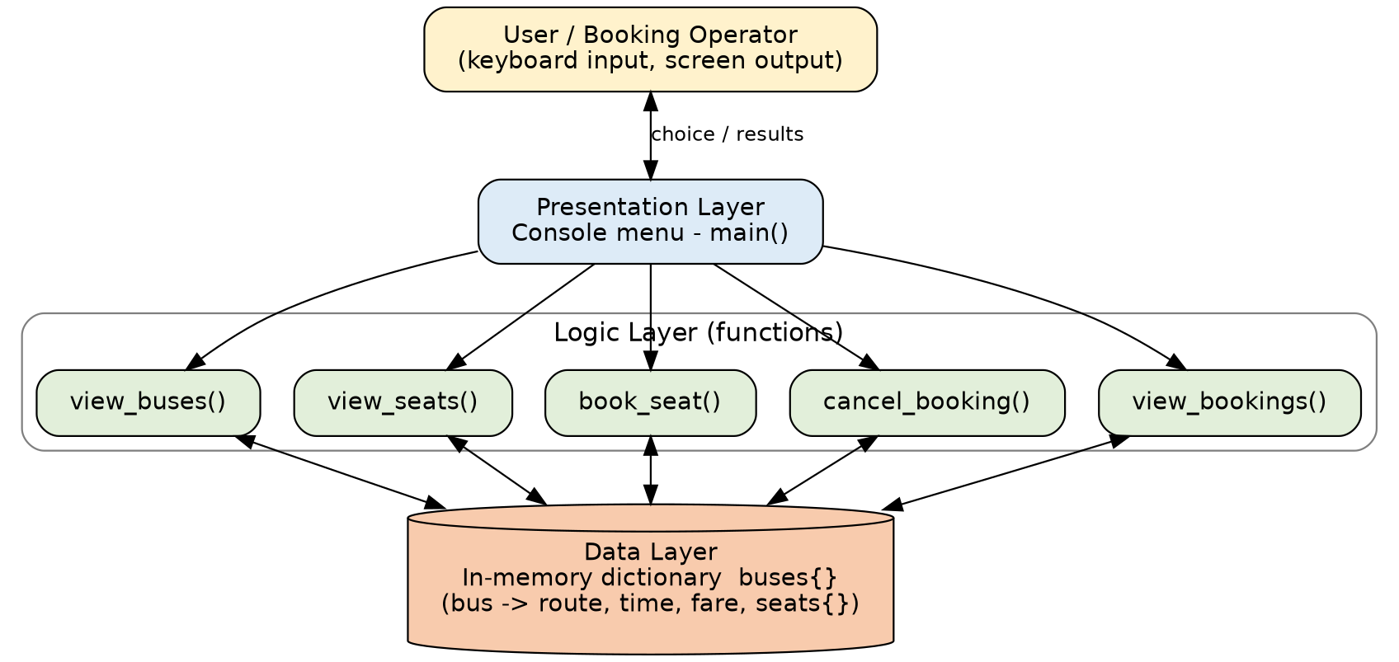
Figure 6.1: Layered architecture of the Bus Reservation System

6.1 Layers
- Presentation layer (main): Displays the menu, reads the user’s choice and calls the matching function. It loops until Exit is chosen.
- Logic layer: view_buses(), view_seats(), book_seat(), cancel_booking() and view_bookings(). They read input, validate it, and read or modify the data.
- Data layer: A nested dictionary. The outer key is the bus number; each bus stores route, time, fare and a seats dictionary. Booked seats are stored in seats with the seat number as key.

6.2 Technology Used
Item | Details
Language | Python 3
Interface | Command-line (console) with text menu
Data storage | In-memory Python dictionary (no database or file)
Libraries | None – only built-in features
Version control | Git / GitHub

7. Design Diagrams

7.1 Use Case Diagram
The only actor is the user (booking operator) who interacts with the system through the menu. The dashed lines show steps that are always performed as part of a use case.
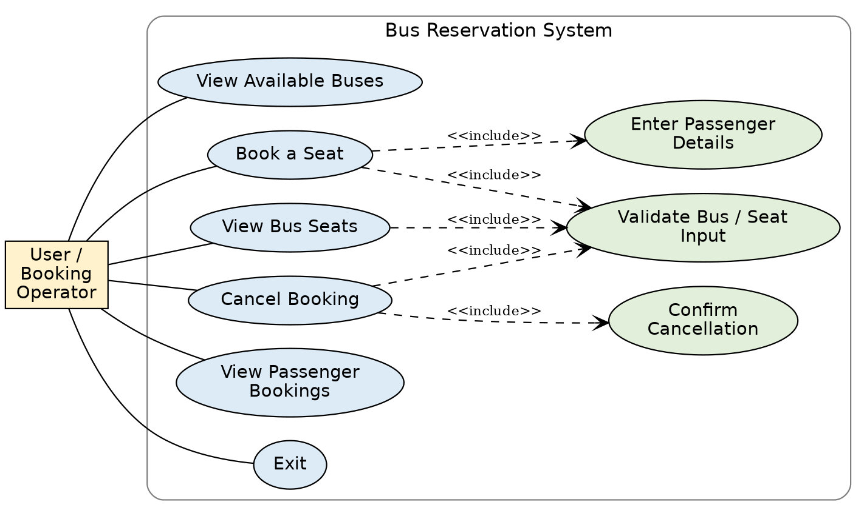
Figure 7.1: Use case diagram

7.2 Workflow Diagram
Figure 7.2 shows the overall flow of the program, and Figure 7.3 shows the detailed flow of the most important operation – booking a seat.
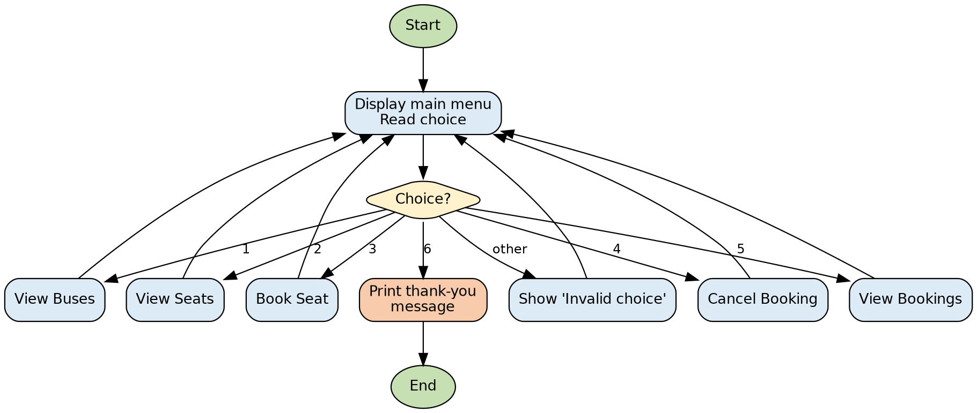
Figure 7.2: Main program workflow
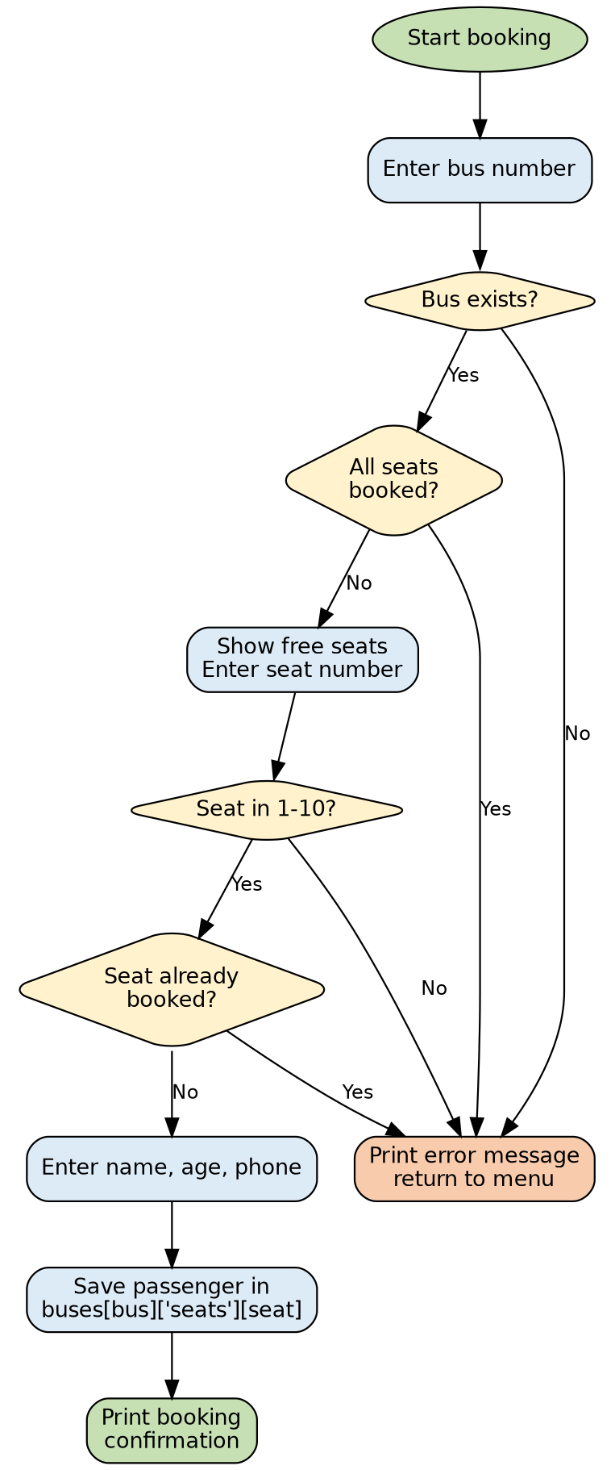
Figure 7.3: Workflow of the Book a Seat operation

7.3 Sequence Diagram
Figure 7.4 shows the messages exchanged between the user, the main menu, the book_seat() function and the buses dictionary during a successful booking.
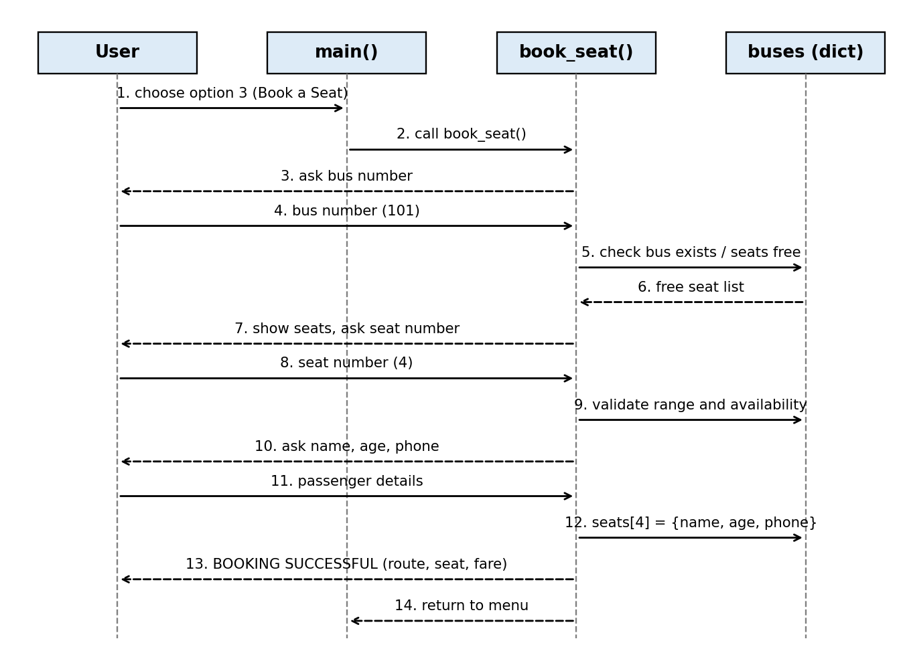
Figure 7.4: Sequence diagram for booking a seat

7.4 Class / Component Diagram
The project does not define classes; it is built from functions. Therefore a component diagram is given, showing each function as a component and how it uses the shared buses dictionary.
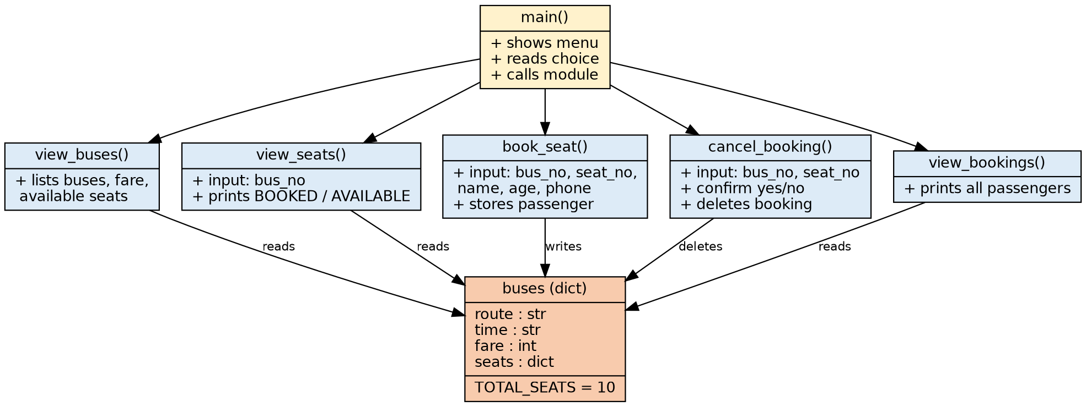
Figure 7.5: Component diagram

7.5 ER Diagram
No database or file storage is used in this version, so a physical ER diagram is not applicable. To document the structure of the data, Figure 7.6 shows the logical data model of the nested dictionary in ER style: one bus has up to ten booked seats, and each booked seat holds exactly one passenger.
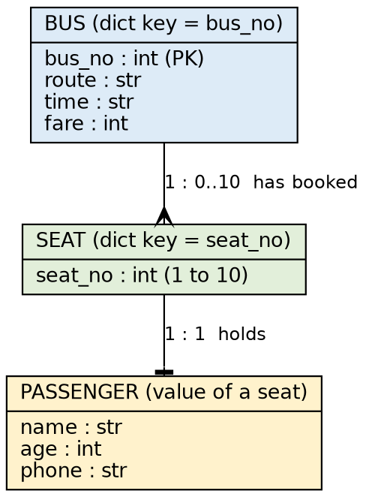
Figure 7.6: Logical data model (in-memory dictionary)
Structure of the data in code:
buses = {
101: {
"route": "Bhopal to Udaipur",
"time": "8:00 AM",
"fare": 350,
"seats": { 4: {"name": "Rahul Sharma", "age": 21, "phone": "9876543210"} }
},
...
}

8. Design Decisions & Rationale
Decision | Rationale
Use a nested dictionary as the data store | Bus number and seat number are natural unique keys. Dictionary lookup is direct and fast, and checking “is this seat booked?” is just seat_no in seats.
Store only booked seats | A seat that is absent from the seats dictionary is available. This avoids keeping a separate list of free seats that could go out of sync; available seats are always calculated as TOTAL_SEATS minus the number of bookings.
Keep TOTAL_SEATS as a constant | The seat count is defined in one place, so it can be changed without editing every function.
One function per operation | Makes the program modular, easy to read, test and extend. main() only decides which function to call.
Console (text) interface | Keeps the focus on program logic, needs no extra software and runs anywhere Python is installed.
try / except ValueError around numeric input | Users may type text where a number is expected. Catching the error keeps the program running and gives a helpful message.
Validate before changing data | Bus number, seat range and seat availability are checked before anything is written, so invalid requests never change the data.
Ask for confirmation before cancelling | Prevents accidental deletion of a booking; the passenger name is shown so the operator can verify it.
Seats numbered from 1 | Matches how seats are numbered on real buses and is easier for users than starting from 0.
In-memory storage (no file or database) | Keeps the first version simple. It is listed as a limitation and as a future enhancement.

9. Implementation Details

9.1 Project Structure
The whole project is a single Python file containing the data, six functions and the call to main():
Element | Purpose
buses (dictionary) | Stores all bus and passenger data
TOTAL_SEATS = 10 | Number of seats in every bus
view_buses() | Lists buses with route, time, fare and available seats
view_seats() | Shows BOOKED / AVAILABLE status for each seat of a bus
book_seat() | Validates input and stores a new booking
cancel_booking() | Finds a booking, asks confirmation and deletes it
view_bookings() | Displays all passenger bookings
main() | Menu loop that calls the above functions

9.2 Key Logic – Booking a Seat
book_seat() applies its checks in a fixed order, so a booking is stored only when every check has passed:
- The bus number must exist in the buses dictionary.
- The bus must not be full (number of booked seats not equal to TOTAL_SEATS).
- The seat number must be between 1 and TOTAL_SEATS.
- The seat must not already be present in the seats dictionary.
- Only then are name, age and phone read and stored.
The core of the code is:
if seat_no < 1 or seat_no > TOTAL_SEATS:
print("Invalid seat number.")
return

if seat_no in buses[bus_no]["seats"]:
print("Sorry, this seat is already booked.")
return

buses[bus_no]["seats"][seat_no] = {
"name": name,
"age": age,
"phone": phone
}

9.3 Key Logic – Available Seats
The number of free seats is never stored; it is calculated when needed, so it can never become inconsistent with the bookings:
available = TOTAL_SEATS - len(bus["seats"])

9.4 Key Logic – Cancelling a Booking
cancel_booking() checks that the bus exists and that the seat is present in the seats dictionary, shows the passenger name, and asks for confirmation. If the answer (converted with lower()) is “yes”, the entry is removed with del, which makes the seat available again.

9.5 Key Logic – Exception Handling
Functions that read numbers (bus number, seat number, age) are placed inside try–except blocks. If the user enters text, int() raises ValueError, which is caught and a message is printed instead of the program stopping.

9.6 How to Run
python bus_reservation.py

The program starts with the main menu; the user enters a number from 1 to 6 to choose an operation. The complete source code is given in the Appendix.

10. Screenshots / Results
The following screens were captured by running the program. In each screen the text after a prompt is the input typed by the user.
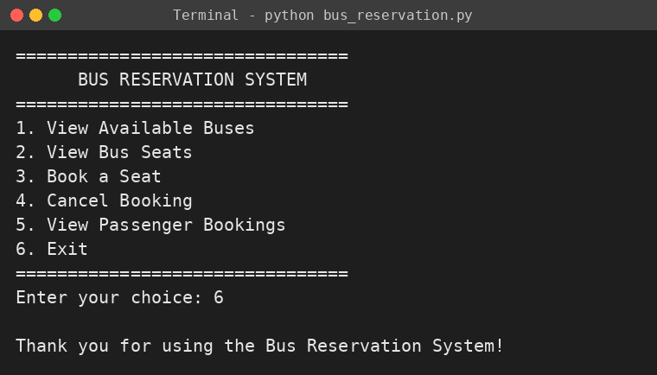
Figure 10.1: Main menu (choice 6 – Exit)
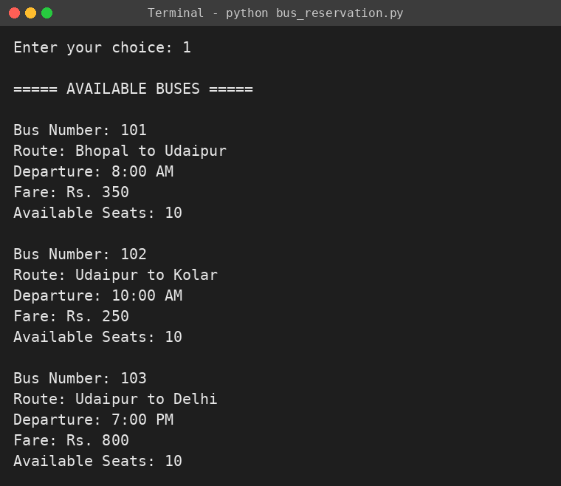
Figure 10.2: View available buses (option 1)
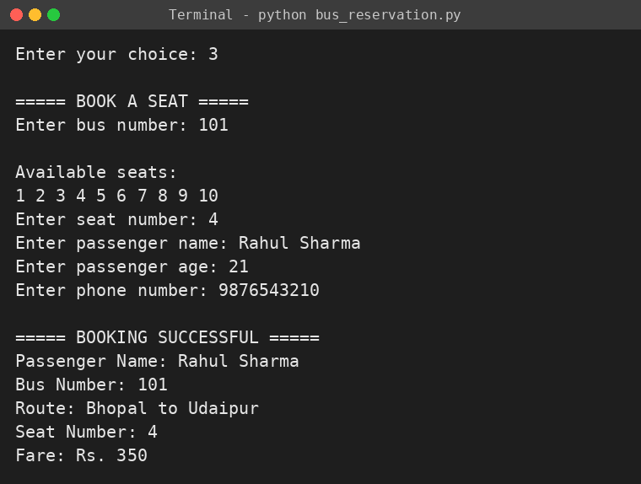
Figure 10.3: Booking a seat (option 3)
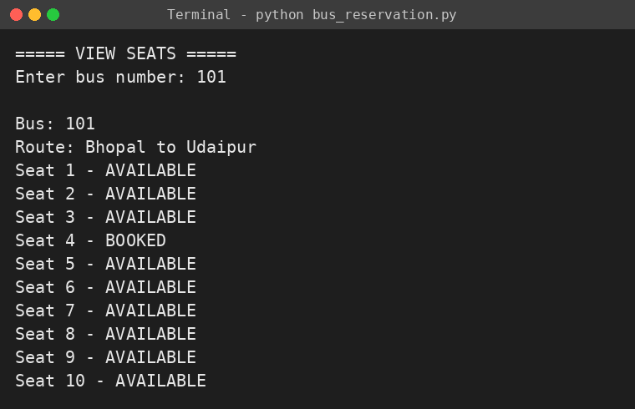
Figure 10.4: Seat status after booking seat 4 (option 2)
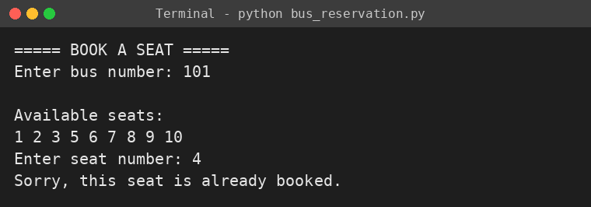
Figure 10.5: Double booking prevented
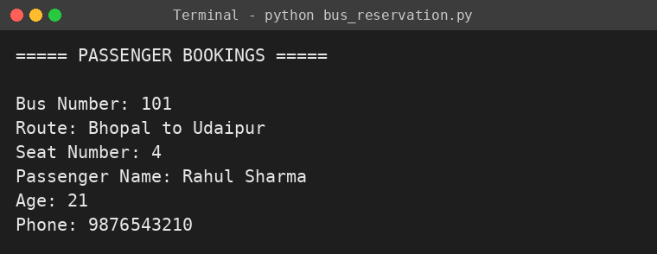
Figure 10.6: Viewing passenger bookings (option 5)
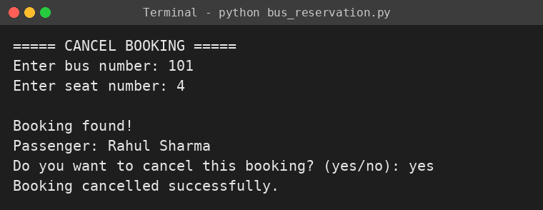
Figure 10.7: Cancelling a booking (option 4)
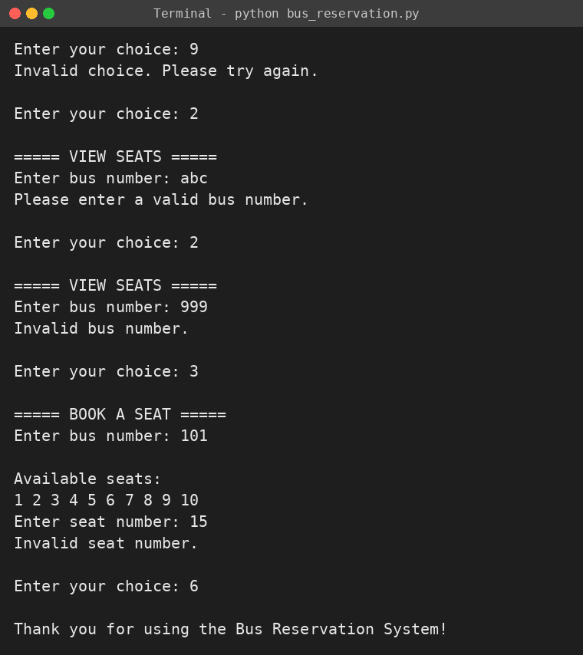
Figure 10.8: Handling invalid input (bad menu choice, text instead of number, unknown bus, seat out of range)

11. Testing Approach
Black-box manual testing was used. Each function was run with valid inputs, invalid inputs and boundary values, and the actual output was compared with the expected output. The program was executed with the inputs listed below and every test behaved as expected.
No. | Test Case | Input | Expected Result | Result
1 | View buses | Menu choice 1 | 3 buses listed, 10 seats available each | Pass
2 | Book a free seat | Bus 101, seat 4, valid details | Booking successful with route and fare | Pass
3 | Seat count updates | View buses after booking | Bus 101 shows 9 available seats | Pass
4 | Double booking | Bus 101, seat 4 again | “Sorry, this seat is already booked.” | Pass
5 | Unknown bus | Bus 999 | “Invalid bus number.” | Pass
6 | Seat out of range | Seat 15 (also boundary 0 and 11) | “Invalid seat number.” | Pass
7 | Text instead of number | Bus number “abc” | Error message, program continues | Pass
8 | Full bus | All 10 seats booked, then book again | “Sorry, all seats are booked.” | Pass
9 | View seats | Bus 101 after booking seat 4 | Seat 4 BOOKED, others AVAILABLE | Pass
10 | Cancel booking – yes | Bus 101, seat 4, “yes” | Booking cancelled, seat free again | Pass
11 | Cancel booking – no | Bus 101, seat 4, “no” | “Booking was not cancelled.” | Pass
12 | Cancel non-existent booking | Bus 102, seat 7 | “No booking found for this seat.” | Pass
13 | View bookings – empty | Menu choice 5 with no bookings | “No bookings available.” | Pass
14 | Invalid menu choice | Choice 9 | “Invalid choice. Please try again.” | Pass
15 | Exit | Choice 6 | Thank-you message, program ends | Pass

12. Challenges Faced
Challenge | How it was handled
Choosing a suitable data structure for buses, seats and passengers | A nested dictionary was chosen so that a bus, a seat and a passenger can each be reached directly using their number as key.
Preventing double booking | The seat is checked against the seats dictionary before any data is written, and the function returns early if it is already booked.
Keeping the available-seat count correct | Instead of storing a counter, the count is calculated from the number of bookings, so it is always accurate after booking or cancelling.
Program crashing on wrong input | try–except ValueError blocks and range checks were added so every invalid entry gives a clear message.
Order of validation in book_seat() | Bus and seat checks were placed before asking for passenger details so the user does not type the details for a booking that will be rejected.
Safe cancellation | A confirmation step showing the passenger name was added to avoid deleting the wrong booking.
Testing many input combinations | A list of test cases covering valid, invalid and boundary values was prepared and run for every function.

13. Learnings & Key Takeaways
- How to model real-world data (buses, seats, passengers) using nested dictionaries.
- How to divide a program into small functions that each do one job, and control them from a menu loop.
- How input validation and exception handling make a program reliable.
- Why checks should be done before modifying data, and why derived values (like available seats) should be calculated instead of stored twice.
- How to design test cases including invalid and boundary inputs.
- How to document a project with requirements, diagrams and design reasoning, and how to manage code using Git and GitHub.

14. Future Enhancements
- Save bookings permanently using files (JSON/CSV) or a database such as SQLite or MySQL, and add an ER diagram for it.
- Add stronger validation: age within a sensible range, 10-digit phone number, non-empty name.
- Add travel dates so that the same bus can be booked on different days.
- Search buses by source and destination; allow buses with different seat counts.
- Add admin and passenger login, and let the admin add, edit or remove buses and fares.
- Generate a printable ticket with a unique ticket (PNR) number; support booking several seats at once.
- Build a graphical interface with Tkinter or a web application with Flask / Django.
- Add payment integration, refund rules and SMS / e-mail confirmation.

15. References
- Python Software Foundation, Python 3 Documentation, https://docs.python.org/3/
- Python Tutorial – Data Structures (Dictionaries), https://docs.python.org/3/tutorial/datastructures.html
- Python Tutorial – Errors and Exceptions, https://docs.python.org/3/tutorial/errors.html
- Graphviz documentation (used to draw the diagrams), https://graphviz.org/documentation/
- Eric Matthes, Python Crash Course, No Starch Press.
- [Add your course material / class notes here]

Appendix: Complete Source Code
# Bus Reservation System

buses = {
101: {
"route": "Bhopal to Udaipur",
"time": "8:00 AM",
"fare": 350,
"seats": {}
},
102: {
"route": "Udaipur to Kolar",
"time": "10:00 AM",
"fare": 250,
"seats": {}
},
103: {
"route": "Udaipur to Delhi",
"time": "7:00 PM",
"fare": 800,
"seats": {}
}
}

TOTAL_SEATS = 10

def view_buses():
print("\n===== AVAILABLE BUSES =====")

for bus_no, bus in buses.items():
available = TOTAL_SEATS - len(bus["seats"])

print("\nBus Number:", bus_no)
print("Route:", bus["route"])
print("Departure:", bus["time"])
print("Fare: Rs.", bus["fare"])
print("Available Seats:", available)

def view_seats():
print("\n===== VIEW SEATS =====")

try:
bus_no = int(input("Enter bus number: "))

if bus_no not in buses:
print("Invalid bus number.")
return

print("\nBus:", bus_no)
print("Route:", buses[bus_no]["route"])

for seat in range(1, TOTAL_SEATS + 1):
if seat in buses[bus_no]["seats"]:
print("Seat", seat, "- BOOKED")
else:
print("Seat", seat, "- AVAILABLE")

except ValueError:
print("Please enter a valid bus number.")

def book_seat():
print("\n===== BOOK A SEAT =====")

try:
bus_no = int(input("Enter bus number: "))

if bus_no not in buses:
print("Invalid bus number.")
return

if len(buses[bus_no]["seats"]) == TOTAL_SEATS:
print("Sorry, all seats are booked.")
return

print("\nAvailable seats:")

for seat in range(1, TOTAL_SEATS + 1):
if seat not in buses[bus_no]["seats"]:
print(seat, end=" ")

print()

seat_no = int(input("Enter seat number: "))

if seat_no < 1 or seat_no > TOTAL_SEATS:
print("Invalid seat number.")
return

if seat_no in buses[bus_no]["seats"]:
print("Sorry, this seat is already booked.")
return

name = input("Enter passenger name: ")
age = int(input("Enter passenger age: "))
phone = input("Enter phone number: ")

buses[bus_no]["seats"][seat_no] = {
"name": name,
"age": age,
"phone": phone
}

print("\n===== BOOKING SUCCESSFUL =====")
print("Passenger Name:", name)
print("Bus Number:", bus_no)
print("Route:", buses[bus_no]["route"])
print("Seat Number:", seat_no)
print("Fare: Rs.", buses[bus_no]["fare"])

except ValueError:
print("Please enter valid information.")

def cancel_booking():
print("\n===== CANCEL BOOKING =====")

try:
bus_no = int(input("Enter bus number: "))

if bus_no not in buses:
print("Invalid bus number.")
return

seat_no = int(input("Enter seat number: "))

if seat_no not in buses[bus_no]["seats"]:
print("No booking found for this seat.")
return

passenger = buses[bus_no]["seats"][seat_no]

print("\nBooking found!")
print("Passenger:", passenger["name"])

confirm = input("Do you want to cancel this booking? (yes/no): ")

if confirm.lower() == "yes":
del buses[bus_no]["seats"][seat_no]
print("Booking cancelled successfully.")
else:
print("Booking was not cancelled.")

except ValueError:
print("Please enter valid information.")

def view_bookings():
print("\n===== PASSENGER BOOKINGS =====")

found = False

for bus_no, bus in buses.items():
for seat_no, passenger in bus["seats"].items():

found = True

print("\nBus Number:", bus_no)
print("Route:", bus["route"])
print("Seat Number:", seat_no)
print("Passenger Name:", passenger["name"])
print("Age:", passenger["age"])
print("Phone:", passenger["phone"])

if not found:
print("No bookings available.")

def main():
while True:

print("\n================================")
print(" BUS RESERVATION SYSTEM")
print("================================")
print("1. View Available Buses")
print("2. View Bus Seats")
print("3. Book a Seat")
print("4. Cancel Booking")
print("5. View Passenger Bookings")
print("6. Exit")
print("================================")

choice = input("Enter your choice: ")

if choice == "1":
view_buses()

elif choice == "2":
view_seats()

elif choice == "3":
book_seat()

elif choice == "4":
cancel_booking()

elif choice == "5":
view_bookings()

elif choice == "6":
print("\nThank you for using the Bus Reservation System!")
break

else:
print("Invalid choice. Please try again.")

main()

